Phytolaccoid Characteristics in Relation to Climate Conditions

Gwendolyn Lloyd, Kerkhoff Lab

May 2016

Tropical Conservatism Hypothesis states that plants originated in the tropics and as they evolved, they migrated out towards the poles. Due to the variation between climates, plants evolved their traits to survive these colder climates. In this study, we looked at a clade known as “Phytolaccoids” and how growth form and seed mass are influenced by changing climate conditions. We observed that woody plants were more abundant in the tropics than in colder environments, reflective of the literature stating that woody plants evolved and spread more slowly from the tropics than herbaceous plants. Additionally, as the temperature grows colder, seed mass decreases; this may be reflective of the nutrient availability in these environments.

Introduction

Many ecological questions can be explained through evolutionary patterns. Trait spread across ecosystems or ranges represent change over time. Through similar studies, the Tropical Conservatism Hypothesis has been used to help explain plant variation. The Tropical Conservatism Hypothesis states that evolutional transitions from tropical to temperate environments are relatively rare because adaptations to a colder and drier climate where seasonal variation is found is more difficult (Mittelbach, 2007). Across the globe the greater diversity found in the tropics helps support this hypothesis (Fine, 2006), yet less is known regarding the specific climate conditions which caused such trends.

The traits which were used in this study included seed mass and growth form. Both functional traits help provide a greater pattern regarding the plant’s growth and reproductive ability, and are frequently used together with other traits such as leaf area or nitrogen content to fully explain plant characteristics (Reich, 2003). Seed mass represents the reproductive ability of the plant, and also the resources available in the environment. An environment with mainly plants that produce small seeds means that there is high seedling competition (Moles, 2006), and the environment is nutrient rich enough to supply the seedlings (Vitousek, 1986). Additionally, the small seeds allow for greater dispersal, whether through physical means or through pollinators. Therefore different seed types reflect a variation of environmental conditions.

Likewise, there is evidence that woody plants have evolved more slowly than herbaceous plants, due to their long generation time (Smith, 2009). The differences between these two plant types span beyond than the generation time. Herbaceous vegetation spreads across the globe and through various climate conditions, as it is rapidly dispersed and aggressive when entering a new environment (Sinnott, 1915). While both growth forms are well represented amongst angiosperms, the environmental conditions in which they are present vary and thus the presence of this functional trait is a good representation of the progression of species entering the region.

Due to the broad range of traits found within this clade, the model organisms chosen was a group of three angiosperm families collectively known as “Phytolaccoids”. Phytolaccoids are formed from the families: *Phytolaccaceae*, *Sarcobataceae*, and *Nyctaginaceae*. Plant types within this range vary from pokeweed (with long leaf stalks and a fleshy taproot) to saltbush (with spiny branches and succulent leaves), yet these species are all closely related within their clade, making them ideal models for determining adaptations. Additionally, this clade can be found in various climates as the Phytolaccoids span across the Americas, ranging from temperate forests to the tropics (Appendix 1).

Recently, studies regarding hypervolumes have been able to show that different trait types are found within different climates, demonstrating limits to potential plant traits (Diaz, 2016). Because there appears to be a correlation between plant traits and climate conditions, we can draw conclusions regarding the evolutionary changes which have taken place resulting in the current trait spread.

Due to tropical conservatism hypothesis, we can assume that plant traits originated in the tropics and expanded out towards the poles. Literature states that woody growth takes longer to evolve than herbaceous plants. As a result, more woody plants should be found in warmer environments. Likewise, the tropics are a region which is very nutrient rich and has rapid nutrient cycling due to the warmer temperatures, so smaller seeds are expected in more tropical environments.

Methods

Plant trait and geographic data was extracted from the Botanical Information and Ecology Network (BIEN). Plant growth form and duration were found by searching the USDA PLANTS database. Lastly, climate data (Bioclim) was used courtesy of Worldclim.

In order to be used together, the raw data from these sources were cleaned up and reformatted into a large data sheet. After various analyses, including tree models and linear models, were used to find relationships between traits and the climate in which they are present. Due to limitations of the dataset, analyses were only able to be performed on the seed and growth form data. In addition to statistics, maps were made using plant ranges in order to support the trends displayed by the data. Phytolaccoid species with trait data available and the traits are found in Appendix 2. The code used can be found in Appendix 3.

Results

*Seed Mass*: Larger seeds (greater than a log seed mass of -4.363) are found in environments with an annual mean temperature of 13.5°C or colder. In environment warmer than this, seed mass is influenced by isothermality, which is defined as the mean diurnal range for each month over the annual temperature range. In these warmer environments, more isothermal environments (with an isothermality greater than 0.462) have smaller seeds than those with a greater climate flux.

While these two climate conditions appear to explain the majority of the seed variation, separately they have a weak relationship (Figure 1, 2). However, the strongest model for explaining the variation in seed mass consists of mean annual temperature, mean diurnal range, isothermality, and temperature seasonality (GLM, f=21.97, df=20, p=4.39x107, adj r2=0.778).

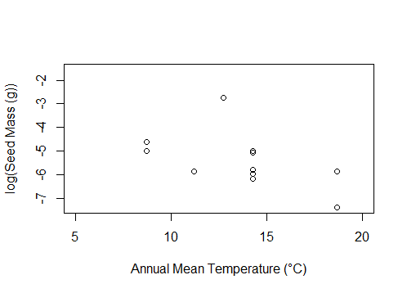

Figure 1. Influence of annual mean temperature (°C) on the log of seed mass (g), (GLM, f=12.37, df=23, p=0.0018, adj r2=0.322).

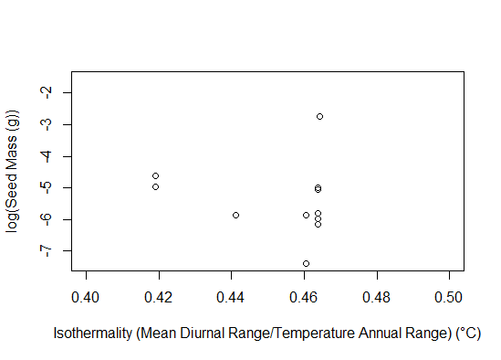

Figure 2. Influence of isothermality on the log of seed mass (g), (GLM, f=1.31, df=23, p=0.264, adj r2=0.0127).

*Growth Form:* In warmer environments, where the mean annual temperature is greater than 19.83 °C, trees dominate the landscape. However in the colder climates, the types of plants present are influenced by precipitation of the driest month (greater than or less than 3.26mm). Herbaceous plants remain the dominant plant in these colder environments despite the amount of precipitation in the driest month.

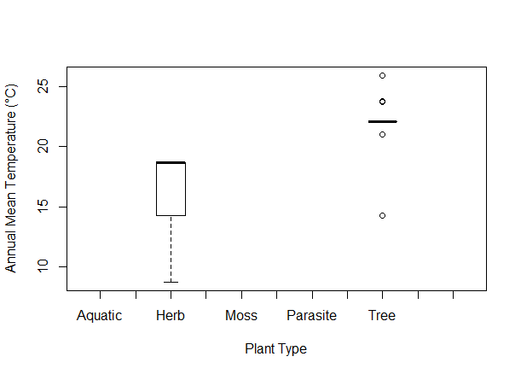

Figure 3. Plant types present across different ranges of annual mean temperature (°C).

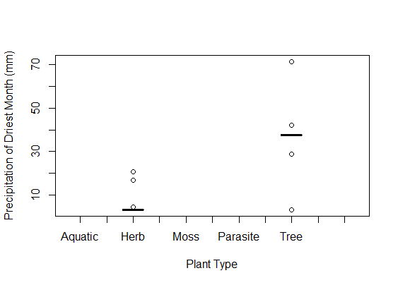

Figure 4. Plant types present across varying ranges of precipitation in the driest month (mm).

Discussion

This study sought to explain trends which are seen for species traits across different climates. Due to the tropical conservatism hypothesis, we predicted that the growth form and seed size would follow a gradient as temperature and other climate variables changed from the equator to the poles. This is reflected by the trends which were observed through tree models and linear models. Seed size appeared to be correlated with temperature, with larger seeds tending to be present in colder environments (Figure 1). However, this trend is not significant, meaning that the trends may be more complex, and other environmental factors may play a role such as nutrient availability or dispersal range, and temperature is a stand-in for these variables. Nevertheless, in warmer environments, or those with a mean annual temperature warmer than 13.5°C, the isothermality of the environment, or how constant the temperatures remain, significantly influences seed size. In environments which have a greater isothermality, smaller seeds are more abundant (Figure 2). This again could be explained as environments which have less seasonal flux provide the characteristics necessary for smaller seed size. Smaller seeds take longer germinating in the soil, but also there is a lower survival rate than large seeds (Moles, 2006). However, dispersing more seeds suggests that there may be high competition in these environments, reflecting the high biodiversity of the tropics, and having many small seeds allows the parent plant to put a little effort into each new seedling.

In addition, woody plants are found most abundantly in the tropics, due their long generation times, and the energy expenditure they require. As a result, these plants evolve slower than their herbaceous counterparts and are more prominent in the tropics due to Tropical Conservatism Hypothesis (Smith, 2009). This is reflective of our observations where woody plants appear to dominate environments with warm average temperatures (Figure 3). However, the distributions we see may not be entirely accurate, as it suggests that there are no herbaceous plants from this clade in the tropics. While these plants may be limited, the lack of herbaceous plants in temperatures warmer than 19.83 °C is a reminder that the data available is limited, and these trends may are a result of the sample size available rather than the actual observed characteristics, yet they are able to explain general biological trends.

While I’m personally pleased with the work that I’ve put into this project, there were many things which I was unable to complete due to lack of time. First, rather than look at the climate variables, it would be interesting to look at the traits across different biomes. Biomes present a narrow range of climate conditions, and also look at the climate conditions holistically, rather than individually. This will hopefully explain the non-significant climate variables which appear significant when combined. Additionally, I hoped to look at species ranges and see whether range size or number of biomes in which a species falls has an influence. Smaller range sizes may mean lower seed dispersal, so the seeds may be larger or they may have to compete with one another more during germination. Additionally, a species may fall in many biomes and have a large range of traits associated with it, which may influence the characteristics of the plants. Lastly, Bennett Stephens initially focused on the Phytolaccoids in relation to phylogenies and applying the climate variables to a phylogeny would greatly help explain evolutionary patterns.

Overall many trends were seen within these species, with seeds increasing in size as temperature decreased, and more woody plants seen in the tropics than in colder environments. While it would be ideal to see these patterns in more plant traits, or over a larger sample size, these observations were reflective of those found in the literature. These trends are evidence that we can use big data to model evolutionary trends from the characteristics currently available to us, and through studies such as these, we can understand the world around us a little better.

Acknowledgements

The members of Kerkhoff lab were helpful in giving feedback and providing code and assistance, particularly, Alton Barbehenn and Cecina Babich Morrow. Professor Kerkhoff was extremely helpful in giving this project direction and advice on how to answer the questions we were asking. Lastly, the following databases provided the resources allowing this project to occur: BIEN (The Botanical Information and Ecology Network), USDA (PLANTS), and Worldclim.

Works cited

Díaz, Sandra, et al. "The global spectrum of plant form and function." *Nature* 529.7585 (2016): 167-171.

Fine, Paul VA, and Richard H. Ree. "Evidence for a time-integrated species-area effect on the latitudinal gradient in tree diversity." The American Naturalist 168.6 (2006): 796-804.

Mittelbach, Gary G., et al. "Evolution and the latitudinal diversity gradient: speciation, extinction and biogeography." *Ecology letters* 10.4 (2007): 315-331.

Moles, Angela T., and Mark Westoby. "Seed size and plant strategy across the whole life cycle." *Oikos* 113.1 (2006): 91-105.

Reich, P. B., et al. "The evolution of plant functional variation: traits, spectra, and strategies." *International Journal of Plant Sciences* 164.S3 (2003): S143-S164.

Sinnott, Edmund W., and Irving W. Bailey. "The evolution of herbaceous plants and its bearing on certain problems of geology and climatology." *The Journal of Geology* 23.4 (1915): 289-306.

Smith, Stephen A., and Jeremy M. Beaulieu. "Life history influences rates of climatic niche evolution in flowering plants." *Proceedings of the Royal Society of London B: Biological Sciences* 276.1677 (2009): 4345-4352.

Vitousek, Peter M., and R. L. Sanford. "Nutrient cycling in moist tropical forest." *Annual review of Ecology and Systematics* (1986): 137-167.

Appendix 1

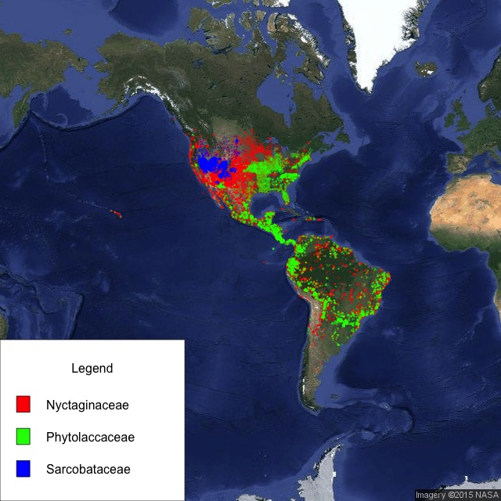

Figure 5. Map displaying the locations of the Phytolaccoid families across the Americas. The three families are able to cover many varying climates and a broad range of latitudes. (Courtesy of Alton Barbehenn)

*Climate Maps*: These maps are courtesy of Worldclim.

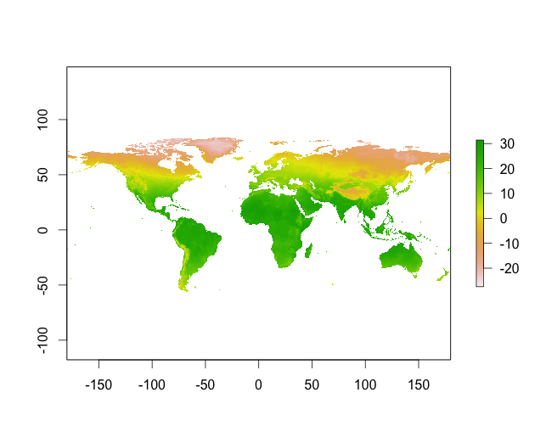

Figure 6. World map displaying BIO1, Mean Annual Temperature, ranges across the globe. Temperatures are recorded in degrees Celsius.

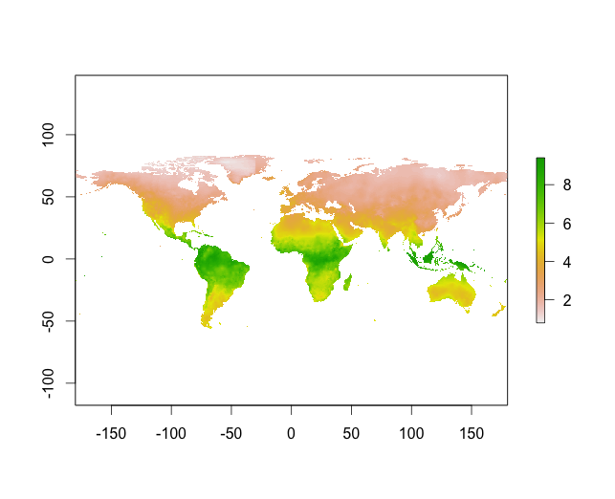

Figure 7. World map displaying BIO3, Isothermality, ranges across the globe. Isothermality is defined as Mean Diurnal Range/ Temperature Annual Range.

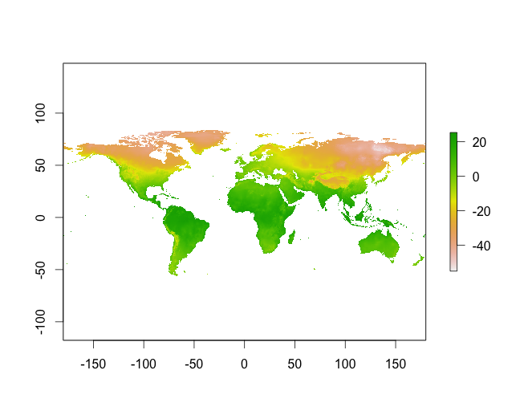

Figure 8. World map displaying BIO6, Min Temperature of Coldest Month, ranges across the globe. Temperatures are recorded in degrees Celsius.

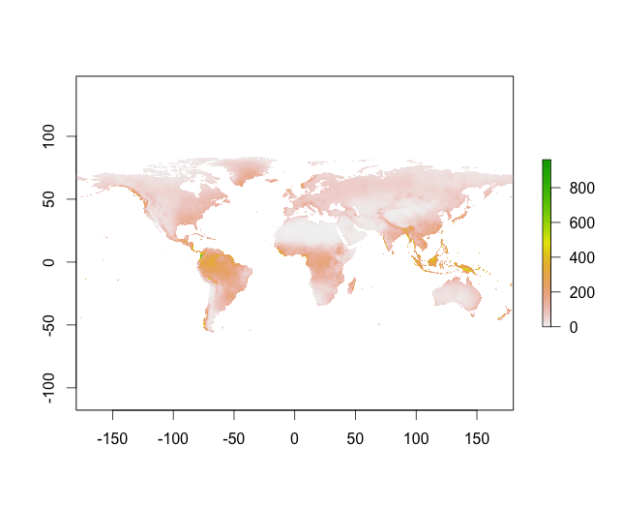

Figure 9. World map displaying BIO12, Annual Precipitation, ranges across the globe. Precipitation is measured in millimeters.

Appendix 2

*Species List:*

Abronia latifolia

Abronia maritima

Abronia pogonantha

Abronia umbellata

Abronia villosa

Allionia hirsuta

Allionia incarnata

Boerhavia coccinea

Boerhavia diffusa

Boerhavia erecta

Boerhavia glabrata

Bougainvillea praecox

Gallesia integrifolia

Guapira costaricana

Guapira cuspidata

Guapira discolor

Guapira myrtiflora

Guapira opposita

Mirabilis bigelovii

Mirabilis californica

Mirabilis greenei

Mirabilis hirsuta

Mirabilis jalapa

Mirabilis multiflora

Neea amplifolia

Neea divaricata

Neea floribunda

Neea hermaphrodita

Neea krukovii

Neea madeirana

Neea obovata

Neea oppositifolia

Neea ovalifolia

Neea psychotrioides

Neea tristis

Oxybaphus nyctagineus

Phytolacca americana

Phytolacca dioica

Phytolacca rivinoides

Pisonia grandis

Pisonia macranthocarpa

Pisonia rotundata

Pisonia subcordata

Pisonia umbellifera

Pisonia zapallo

Ramisia brasiliensis

Rivina humilis

Seguieria langsdorffii

*Trait List:*

Duration (USDA)

Growth Form (USDA and BIEN)

Bioclim Variables 1-19

From BIEN:

Area-based Photosynthesis

Mass-based Photosynthesis

Flowering Date

Flowering Month

Height

Leaf Area

Leaf C mass

Leaf N area

Leaf N mass

Leaf P mass

Seed Mass

Specific Leaf Area (SLA)

Stomatal conductance

Wood Density

Appendix 3

###Phytolaccoid Project###  
#Goals: Collecting information about traits over area and climate

*#Creating allspecies_alltraits datasheet*

##Getting Data from BIEN######################################  
source('your/working/directory/BIEN_public_API.R')  
  
*#These three families are the Phytolaccoids*  
family_vector<-c("Phytolaccaceae", "Sarcobataceae", "Nyctaginaceae")  
#Getting a list of species  
family_loc_data <- BIEN.gis.family(family_vector)  
species_vector = unique(family_loc_data[2])  
species_vector = na.omit(species_vector)  
#View(species_vector) #These are the species  
  
*#Getting trait values for these species*   
##trait_vector contains all traits from BIEN  
trait_vector <- c("trait_name", "Area-based photosynthesis (Aarea)", "Flowering date", "Flowering month", "Height", "Leaf area", "Leaf Cmass", "Leaf dry mass", "Leaf dry matter content (LDMC)", "Leaf Narea", "Leaf Nmass", "Leaf Parea", "Leaf Pmass", "Mass-based photosynthesis (Amass)", "seed mass", "Specific leaf area (SLA)", "Stomatal conductance (Gs)", "wood density")  
trait_data <- BIEN.trait.traitbyspecies(trait = trait_vector, species = species_vector[,1])  
  
#Data Clean-up  
*#traits from BIEN are all listed together in a single column, separating them makes them usable*  
library(tidyr)  
trait.spread=spread(trait_data, trait_name, trait_value)  
  
#optional: removing extra columns that you don't want to use:  
##trait.spread$intraspecific_rank <- NULL  
##trait.spread$varsubsp <- NULL

##Growthform Data#########################################  
*#Growth form data was manually imported into a csv file from USDA.gov and from BIEN*  
  
*#Growthform data from BIEN  
#import Growthform_Final.csv (found on Kerkhoff Lab Google Drive)*  
  
#get a list of species which you want to look at the trait data  
##if you already have one these steps aren't necessary  
#specieslist <- allspecies_alltraits[4]  
#specieslist= unique(specieslist)  
  
*#Get the Growthform data for a particular list of species*  
BIENgrowthform <- merge(specieslist, Growthform_Final, by="taxon", by.y= "LATIN")  
  
#There will be other things in the data sheet, you can remove them if you don't want excess columns   
#BIENgrowthform$FAMILY <- NULL  
#BIENgrowthform$GENUS <- NULL  
#BIENgrowthform$SPECIES <- NULL  
#BIENgrowthform$ID <- NULL  
#BIENgrowthform$X <- NULL  
#BIENgrowthform$X.1 <- NULL  
#BIENgrowthform$X.2 <- NULL  
#BIENgrowthform$SOURCES <- NULL  
#BIENgrowthform$CONSENSUS <- NULL  
  
#attach this trait to the already existing datasheet  
allspecies_alltraits <- merge(allspecies_alltraits, BIENgrowthform, by="taxon")  
  
##USDA traits are duration and growth.type, both were manually imported  
##BIEN growthform traits are the column GROWTHFORM

##Getting Bioclim Variables###############################  
  
*#download bioclim variables from worldclim.org  
#make sure your working directory is where the bioclim data is present*wd <- setwd("PLACE PATHWAY HERE")  
  
bio_1 = raster("bio_1.bil")  
bio_2 = raster("bio_2.bil")  
bio_3 = raster("bio_3.bil")  
bio_4 = raster("bio_4.bil")  
bio_5 = raster("bio_5.bil")  
bio_6 = raster("bio_6.bil")  
bio_7 = raster("bio_7.bil")  
bio_8 = raster("bio_8.bil")  
bio_9 = raster("bio_9.bil")  
bio_10 = raster("bio_10.bil")  
bio_11 = raster("bio_11.bil")  
bio_12 = raster("bio_12.bil")  
bio_13 = raster("bio_13.bil")  
bio_14 = raster("bio_14.bil")  
bio_15 = raster("bio_15.bil")  
bio_16 = raster("bio_16.bil")  
bio_17 = raster("bio_17.bil")  
bio_18 = raster("bio_18.bil")  
bio_19 = raster("bio_19.bil")  
raster_vector <- c(bio_1, bio_2, bio_3, bio_4, bio_5, bio_6, bio_7, bio_8, bio_9, bio_10, bio_11, bio_12, bio_13, bio_14, bio_15, bio_16, bio_17, bio_18, bio_19)  
df <- data.frame(Species = character(), Bio1 = double(), Bio2 = double(), Bio3 = double(), Bio4 = double(), Bio5 = double(), Bio6 = double(), Bio7 = double(), Bio8 = double(), Bio9 = double(), Bio10 = double(), Bio11 = double(), Bio12 = double(), Bio13 = double(), Bio14 = double(), Bio15 = double(), Bio16 = double(), Bio17 = double(), Bio18 = double(), Bio19 = double())  
  
library(raster)  
#this will literally take forever omg like let this run and do something else  
#you should only have to do this once though  
raster_brick <- brick(raster_vector)  
  
current_dir = wd  
#make sure this is actually where your shape files are!!!!  
  
#this will also take forever  
*#query databse for range polygons for each species*  
for(i in 1:length(all_species)) {  
 #get range polygon  
 path = paste0(current_dir, "/", all_species[i], ".shp")  
 range_poly<-readShapePoly(path)  
 #get mean  
 temp_brick <- crop(raster_brick, range_poly)  
 data = cellStats(temp_brick, 'mean')  
 #build data entry  
 row <- c(all_species[i], data)  
 #add data to dataframe  
 df <- row.add(df, row)  
}  
  
*#The Bioclim variables are multiplied by 10 because decimals are larger than integers so adjust them before doing any statistics  
#Adjustment variables came from https://github.com/eightysteele/Spatial-Data-Library/issues/20*  
*#These should be right just make sure that bio1 is the 3rd column before you run it?*  
df[3]=df[3]/10  
df[4]=df[4]/10  
df[5]=df[5]/100  
df[6]=df[6]/100  
df[7]=df[7]/10  
df[8]=df[8]/10  
df[9]=df[9]/10  
df[10]=df[10]/10  
df[11]=df[11]/10  
df[12]=df[12]/10  
df[13]=df[13]/10  
  
#if you want to save this as a csv file  
#write.csv(df, file = "bioclim_rangedata.csv")  
  
#add this to the already existing datasheet  
allspecies_alltraits=merge(trait.spread, df, by="taxon")  
  
### if needed rename things with this!!  
##names(dataset)[names(dataset)=="original column name"] <- "new column name"

*#Maps and Other Geographic Things#*  
##Extracting Geographic Data###########################  
#All examples use Rivina humilis  
library(rgeos)  
library(rgdal)  
library(maptools)  
  
*#You should have these range polygons if you extracted Bioclim data but if you can do this if you need them  
#this and later commands grab shapes from your working directory, so make sure that they are there*  
BIEN.ranges.species(species_vector)  
BIEN.ranges.species("Rivina humilis")  
  
#Reading shape files  
poly <- readShapePoly("Rivina_humilis")

#Plotting shape files###################################  
map('world', fill = TRUE, col = "grey") #plots a world map (WGS84 projection), in forest grey  
plot(poly,col="forest green",add=TRUE)  
  
*#plotting points on Google Maps*  
library(Rgooglemaps)  
library(stats)  
library(scales)  
library(graphics)  
  
df <- data.frame(latitude=double(), longitude=double(), color=character(), name=character())  
for (i in 1:length(vector)) {  
 vector <- BIEN.gis.species("Rivina humilis")  
 tmp <- vector[2:3]  
 tmp = na.omit(tmp)  
 tmp$color <- alpha("red", 0.3)  
 temp_dataframe = data.frame(tmp[1], tmp[2])  
 df <- rbind(df, temp_dataframe)  
}  
  
lon_range <- c(min(df$longitude), max(df$longitude))  
lat_range <- c(min(df$latitude), max(df$latitude))  
  
mymap <- GetMap.bbox(lon_range, lat_range, destfile = "TestGoogleMap.png", maptype="satellite", zoom=2, size=c(640,640))  
PlotOnStaticMap(mymap, lon=df$longitude, lat=df$latitude, pch=20, cex = .25, col="red")  
  
#mypolygon <- drawPoly() # click on the map to draw a polygon and press ESC when finished  
#summary(mypolygon)   
  
*#plotting shape files (species ranges) on Google Maps*  
library(ggmap)  
library(ggplot2)  
shp <- readOGR(".", "Rivina_humilis")  
projection(shp) <- CRS("+proj=tmerc +lat_0=0 +lon_0=9 +k=1 +x_0=3500000 +y_0=0 +datum=potsdam +units=m +no_defs")  
ggplot(data = shp, aes(x = long, y = lat, group = group)) + geom_polygon()  
#CenterOfMap was chosen because BIEN only has information for N and S America but this can be changes  
CenterOfMap <- geocode("Mexico")  
mymap = get_map(c(lon=CenterOfMap$lon, lat=CenterOfMap$lat), source="google", maptype="satellite", zoom=2)  
ggmap(mymap)+ geom_polygon(aes(x = long, y = lat, group = group), data = shp, fill='green')  
  
#Plotting Species over Bioclim data#############################  
#if you need to import bioclim data to R  
#bio_1= raster("bio_1.bil")  
#bio_1 <-bio_1/10  
  
*#Plotting Points with Bioclim*  
gis_data = vector[2:3]  
gis_data = unique(gis_data)  
gis_data = na.omit(gis_data)  
str(gis_data)  
coordinates(gis_data) <- ~longitude+latitude  
proj4string(gis_data) <- CRS("+proj=longlat +datum=WGS84 +no_defs +ellps=WGS84 +towgs84=0,0,0")  
  
plot(bio_1)  
points(gis_data, col = "red", pch = 20, cex = 0.25)  
  
*#Plotting Ranges with Bioclim*  
shp <- readOGR(".", "Rivina_humilis")  
projection(shp) <- CRS("+proj=tmerc +lat_0=0 +lon_0=9 +k=1 +x_0=3500000 +y_0=0 +datum=potsdam +units=m +no_defs")  
  
plot(bio1)  
geom_polygon(aes(x = long, y = lat, group = group), data = shp, fill='green')

#Analysis/Trends  
##Use alltraits_allspecies for this  
  
#Seed data!!  
  
*#preliminary data summary*  
hist(allspecies_alltraits$seed.mass, xlab="Seed Mass (g)", ylab="Frequency", main="")  
text(0.2, 12, "Pisonia umbellifera")  
#outlier is Pisonia umbellifera  
  
*#seed mass for duration*  
plot(log(allspecies_alltraits$seed.mass)~allspecies_alltraits$duration, xlab="Growth Duration", ylab="log(Seed Mass (g))")  
  
*#bioclim variables*  
##contains only variable which had an effect  
seed.model <- lm(log(seed.mass) ~ bio1+bio2+bio3+bio4, data=allspecies_alltraits)  
#plot(seed.model)  
summary(seed.model) #together: f=21.97, p=4.392x10^-7, r2=0.8146  
  
*#trees*  
library(tree)  
tree.model1 <- tree(log(seed.mass) ~ bio1+bio6, data=allspecies_alltraits)  
plot(tree.model1)  
text(tree.model1)  
summary(tree.model1)  
  
tree.model2 <- tree(log(seed.mass) ~ bio1+bio2+bio3+bio4+bio5+bio6+bio7+bio8+bio9+bio10+bio11+bio12+bio13+bio14+bio15+bio16+bio17+bio18+bio19, data=allspecies_alltraits)  
plot(tree.model2)  
text(tree.model2)  
summary(tree.model2)  
  
tree.model3 <- tree(log(seed.mass) ~ bio1+bio2+bio3+bio4, data=allspecies_alltraits)  
plot(tree.model3)  
text(tree.model3)  
summary(tree.model3)  
  
*#supporting bioclim plots*  
plot(log(allspecies_alltraits$seed.mass)~allspecies_alltraits$bio1, xlim=c(5,20), xlab="Annual Mean Temperature (°C)", ylab="log(Seed Mass (g))")  
plot(log(allspecies_alltraits$seed.mass)~allspecies_alltraits$bio3, xlim=c(0.4,0.5), xlab="Isothermality (Mean Diurnal Range/Temperature Annual Range) (°C)", ylab="log(Seed Mass (g))")  
plot(log(allspecies_alltraits$seed.mass)~allspecies_alltraits$bio6, xlim=c(-5,5), xlab="Min Temperature of Coldest Month (°C)", ylab="log(Seed Mass (g))")  
plot(log(allspecies_alltraits$seed.mass)~allspecies_alltraits$bio12, xlab="Annual Precipitation (mm month ^ -1)", ylab="log(Seed Mass (g))")  
  
#Growth form data!!  
  
*#preliminary trends*  
plot(allspecies_alltraits$growth.type)  
plot(bio1~growth.type, data=allspecies_alltraits)  
#bc of the uneven distribution of traits these were ignored:  
plot(allspecies_alltraits$duration)   
  
plot(allspecies_alltraits$GROWTHFORM, ylab="Frequency", xlab="Plant Type")  
plot(bio1~GROWTHFORM, data=allspecies_alltraits, xlab="Plant Type", ylab="Annual Mean Temperature (°C)")  
plot(bio14~GROWTHFORM, data=allspecies_alltraits, xlab="Plant Type", ylab="Precipitation of Driest Month (mm)")  
  
  
*#trees*  
library(tree)  
tree.model <- tree(GROWTHFORM ~ bio1+bio2+bio3+bio4+bio5+bio6+bio7+bio8+bio9+bio10+bio11+bio12+bio13+bio14+bio15+bio16+bio17+bio18+bio19, data=allspecies_alltraits)  
plot(tree.model)  
text(tree.model)  
summary(tree.model)  
  
tree.model1 <- tree(growth.type ~ bio1+bio2+bio3+bio4+bio5+bio6+bio7+bio8+bio9+bio10+bio11+bio12+bio13+bio14+bio15+bio16+bio17+bio18+bio19, data=growthform_bioclim)  
plot(tree.model1)  
text(tree.model1)  
summary(tree.model1)